Topic 4.6

AROMATIC CHEMISTRY

Structure and stability of benzene
Reactions of benzene
Uses of aromatic compounds

BENZENE

1. Structure

Benzene is a cyclic hydrocarbon containing six carbon atoms and six hydrogen atoms. It was originally thought to be a ring of six carbon atoms containing alternate single and double bonds as follows:

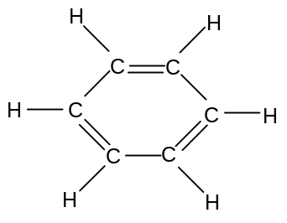

This molecule has the IUPAC name cyclohex-1,3,5-triene. It has the molecular formula C₆H₆ but is usually represented as it skeletal formula:

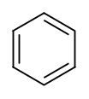

This structure is often known as the Kekule structure.

Double and single bonds do not have the same length; in double bonds, the extra overlap of the π–orbitals brings the atoms closer together and the bond is shorter:

 |  |  | bond | Length/nm
 |  |  | C-C | 0.154
 |  |  | C=C | 0.134

The double bonds would be expected to be shorter than the single bonds in cyclohexa-1,3,5-triene.

Analysis of the molecule, however, shows that this is not in fact the case; the bonds all have a length of 0.142 nm, intermediate between single and double. It was proposed that the structure did not in fact contain alternate single and double bonds but contained delocalized electrons in six overlapping orbitals:

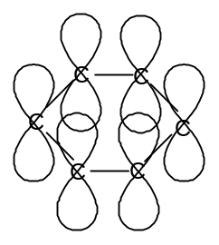

The delocalized electrons can be represented as a circle within the hexagonal ring:

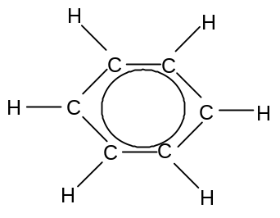

This molecule is known as benzene. It is usually represented by its skeletal formula:

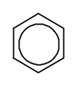
The electrons are completely delocalized. The carbons atoms each form three covalent bonds making the angle between the atoms 120º and the molecule planar.

The structure of benzene thus has the following key features:

- All six –bonded electrons are delocalized

- All six C-C bonds have the same length, intermediate between single and double

- The molecule is planar

Any molecule containing the benzene ring can be described as aromatic.
2. Stability

The delocalization of the electrons in the benzene ring has a significant effect on the stability of the molecule. Benzene might be expected to behave like alkenes; i.e. react readily with bromine and hydrogen to undergo addition reactions, but this is not the case.

The delocalization of the electrons in benzene makes the molecule more stable than expected for a molecule with three double bonds.

This stability can be illustrated by considering the energy change when a molecule of benzene is hydrogenated.

Cyclohexene (C₆H₁₀) can be hydrogenated by breaking one C=C double bond and 1 H-H bond and then forming one C-C single bond and 2 C-H bonds:
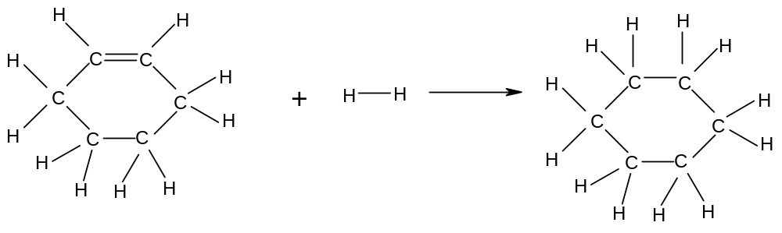
The enthalpy change for this reaction is -120 kJmol⁻¹.

The hydrogenation of benzene involves breaking three C=C double bonds and 3 H-H bonds and then forming three C-C single bond and 6 C-H bonds:
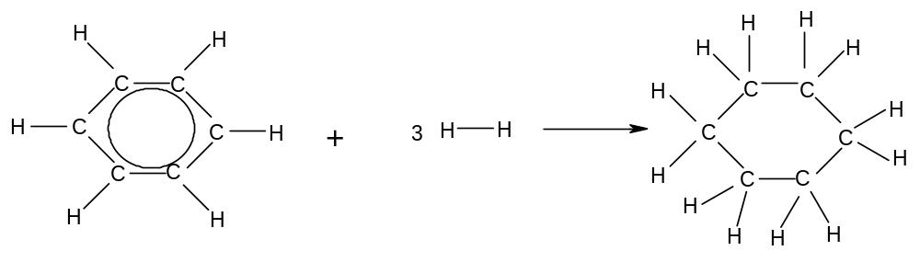
The enthalpy change of this reaction should therefore be exactly three times the hydrogenation of cyclohexene, i.e. 3 x -120 kJmol⁻¹ = -360 kJmol⁻¹.

However the enthalpy change for this reaction is only -209 kJmol⁻¹. This is less exothermic than expected, suggesting that the benzene molecule has much less energy than it would have if the electrons were not delocalized:

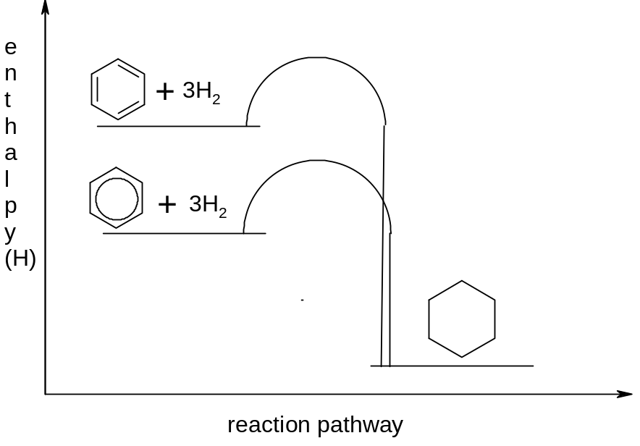

- The enthalpy of hydrogenation of benzene is significantly less than three times the enthalpy of hydrogenation of a typical alkene. This is good evidence that delocalization confers stability to the molecule.

3. Reactions of benzene

As benzene contains carbon-carbon double bonds, it might be expected to undergo addition reactions readily. This is not the case, however, and benzene will not decolorise bromine water. Neither will benzene readily undergo any other addition reactions.

The reason for this is that the delocalized system in benzene is stable, and any reactions, such as addition reactions, which break up the delocalized system will not be favoured.

Benzene thus tends to undergo substitution, rather than addition reactions.

The delocalized electrons constitute an electron-rich area, and they are thus susceptible to attack by electrophiles.

Benzene tends to undergo electrophilic substitution.

There are three important electrophilic substitution reactions of benzene, all of which follow the same mechanism.

a) nitration

Benzene reacts with a 50:50 mixture of concentrated nitric and sulphuric acid, under reflux at 50-55ºC, to form nitrobenzene.

Step 1: Nitric acid is a weaker acid than sulphuric acid, and acts as a base as the electrophile is formed.

H₂SO₄ + HNO₃ → H₂NO₃⁺ + HSO₄⁻
H₂NO₃⁺ → H₂O + NO₂⁺

Step 2: The NO₂⁺ is the electrophile and attacks the delocalised ring, breaking it temporarily:

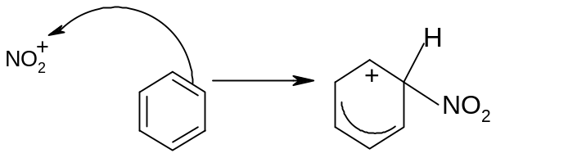

Step 3: The delocalised system then reforms itself by pulling in the electrons from the
C-H bond.
The H⁺ recombines with the HSO₄⁻ to form H₂SO₄.

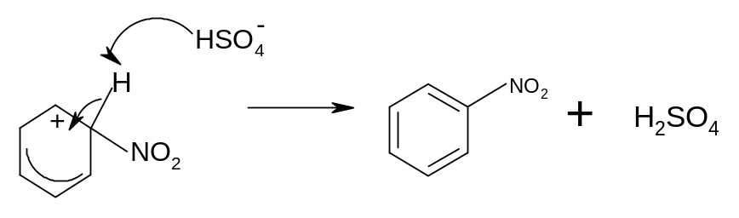

The overall reaction is C₆H₆ + HNO₃ → C₆H₅NO₂ + H₂O

It can also be written:

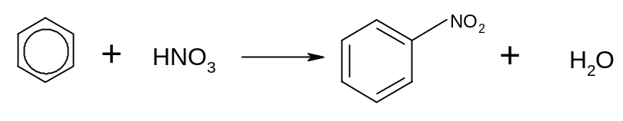

The sulphuric acid behaves as a catalyst. The product is known as nitrobenzene.

b) alkylation

i) using haloalkanes

Benzene reacts with chloroalkanes in the presence of anhydrous AlCl₃ under reflux at 50ºC to form alkylbenzenes.

Step 1: The AlCl₃ accepts a Cl⁻ from the chloroalkane to form a carbocation:

R-Cl + AlCl₃ → R⁺ + AlCl₄⁻

Step 2: The R⁺ is the electrophile and attacks the delocalised ring, breaking it temporarily:

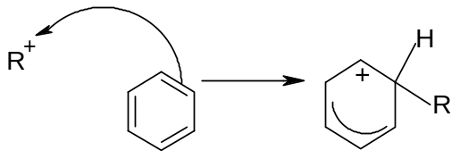
Step 3: The delocalised ring re-forms by taking the electrons from the C-H bond.
The H⁺ reacts with AlCl₄⁻ to produce HCl gas and regenerate AlCl₃.
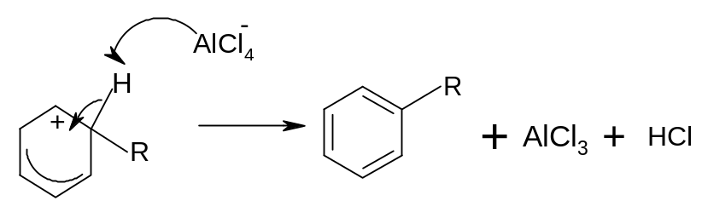
The overall reaction is thus C₆H₆ + RCl → C₆H₅R + HCl

It can also be written:
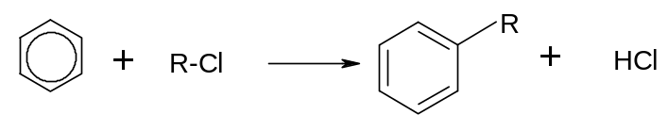
The AlCl₃ acts as a catalyst.

If chloromethane (CH₃Cl) is used, then methylbenzene (C₆H₅CH₃) is formed.
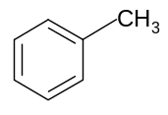
If chloroethane (C₂H₅Cl) is used, then ethylbenzene (C₆H₅C₂H₅) is formed.

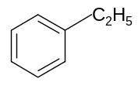
ii) using alkenes

Alkylbenzenes other than methylbenzene can be formed by reacting benzene with alkenes in the presence of HCl and AlCl₃, under reflux at temperatures below 50ºC.

Step 1: The alkene reacts with the HCl in the same way as in electrophilic addition
reactions:

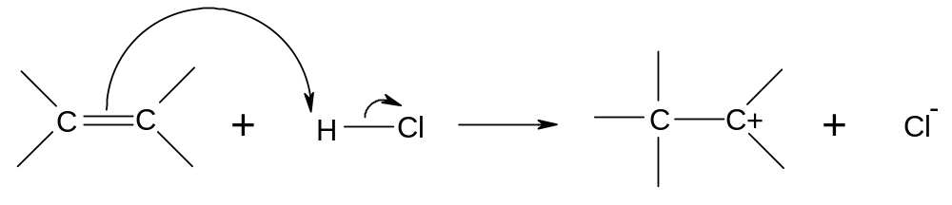
The carbocation behaves as the electrophile.

Step 2 and Step 3 proceed in the same way as in the alkylation reaction described above.

The overall reaction can be written as follows:
C₆H₆ + R₁R₂C=CR₁R₂ → C₆H₅CR₁R₂CR₃R₄

It can also be written as follows:
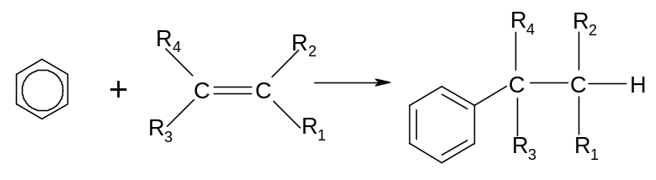
The AlCl₃ and the HCl act as catalysts.

If ethane is used, the main product is ethylbenzene.
Unsymmetrical alkenes can give two possible carbocations when HCl is added. In such cases two different products are possible.
In most cases one carbocation is produced in greater quantities than the other. Thus a major product and a minor product will be formed.

Eg propene can react with HCl to give two possible carbocations:

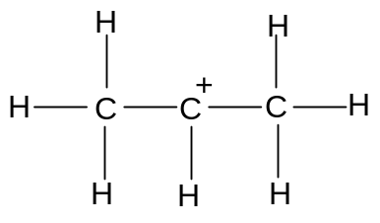 or 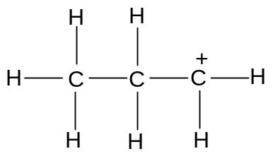
more stable less stable

The more stable cation gives the major product, methylethylbenzene.
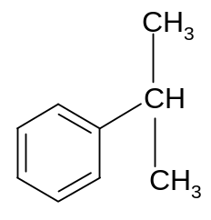

The less stable cation gives the minor product, propylbenzene.
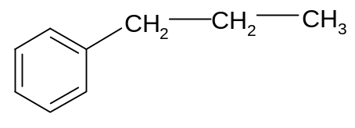

c) acylation

Benzene reacts with acyl chlorides in the presence of anhydrous AlCl₃ under reflux at 50ºC to give phenylketones.

Step 1: The electrophile is generated in the same way as for alkylation.

R-COCl + AlCl₃ → R-CO⁺ + AlCl₄⁻

The R-CO⁺ is the electrophile.

Step 2: The electrophile attacks the delocalised ring, breaking it temporarily:

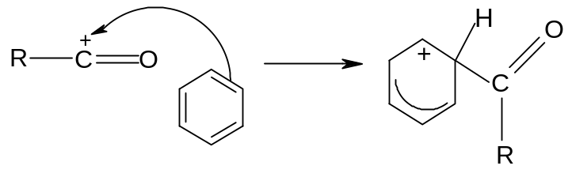

Step 3: The delocalised ring re-forms by taking the electrons from the C-H bond.
The H⁺ reacts with AlCl₄⁻ to produce HCl gas and regenerate AlCl₃:

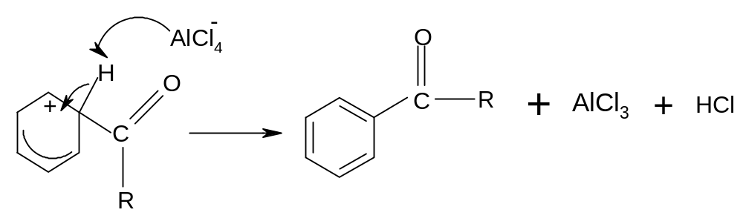

The overall reaction is thus C₆H₆ + R-COCl → C₆H₅COR + HCl
The AlCl₃ is a catalyst.

If ethanoyl chloride is used, then the product is phenylethanone.

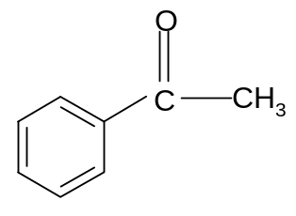

d) further substitution

It is essential that the reaction temperature not be allowed to rise above 55ºC during these reactions. This is because otherwise further substitution will occur:

Eg 1,3 - dinitrobenzene
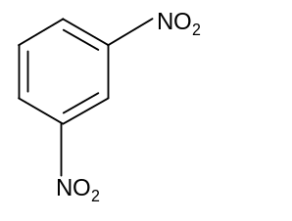
Eg 1,3,5 - trimethylbenzene

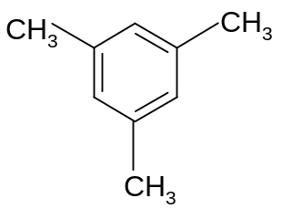

PHENYLAMINE

a) preparation of phenylamine

The main use of nitrobenzene is to make phenylamine, an important aromatic amine.

Nitrobenzene can be reduced to phenylamine by treating it with tin and concentrated HCl and heating under reflux.

The Sn and HCl form SnCl₂, which is a good reducing agent. LiAlH₄ and NaBH₄ should not be used for this reaction since they give other products.

Hydrogen gas could be used in the presence of a suitable catalyst.
The equation for the reaction is as follows:

C₆H₅NO₂ + 6[H] → C₆H₅NH₂ + 2H₂O

It can also be represented as follows:

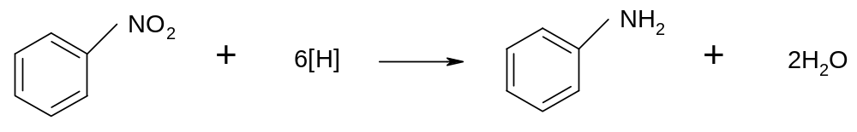

b) basic properties of phenylamine

Phenylamine is a much weaker base than aliphatic amines since the lone pair on the nitrogen atom is absorbed into the delocalised system and is thus not available for bonding with a proton:

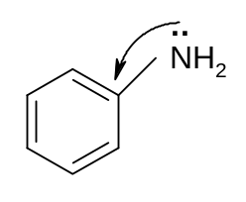
USES OF AROMATIC COMPOUNDS

a) explosives

The explosive trinitrotoluene (TNT) is formed by the nitration of methylbenzene:

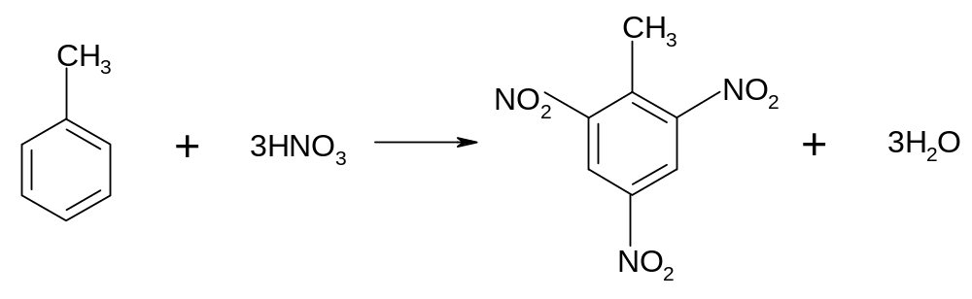
2,4,6-trinitromethylbenzene

b) dyestuffs

Phenylamine can be converted into another important compound, benzenediazonium chloride by reaction with nitrous acid:

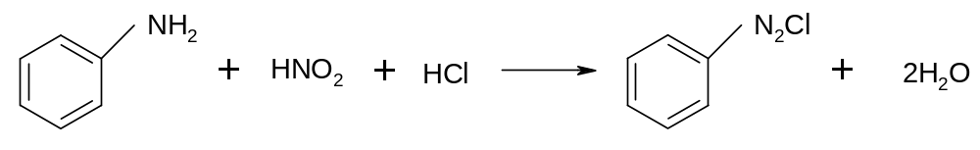
Benzenediazonium chloride can be used to make a number of different dyes:

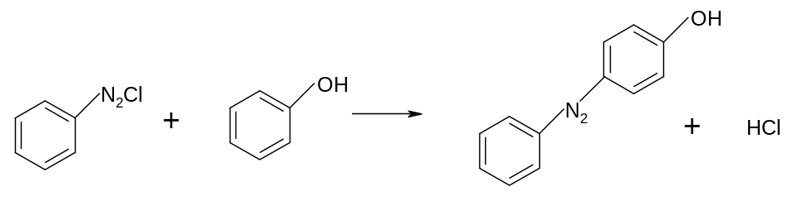

typical dye

c) polystyrene

Ethylbenzene is manufactured industrially from benzene and ethene in the presence of AlCl₃ and HCl

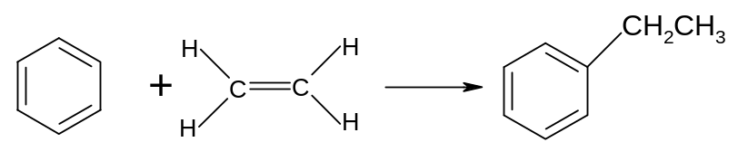
Ethylbenzene can be dehydrogenated to form phenylethene, or “styrene” in the presence of iron oxide at high temperature:

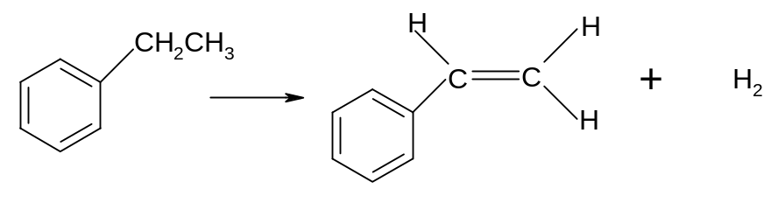
The phenylethene can then be polymerized to form polystyrene (or polyphenylethene)

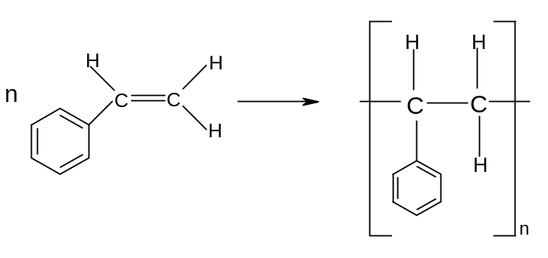

The uses of aromatic compounds can be summarized as follows:

- Many explosives are made by the nitration of benzene derivatives

- Phenylamine is used to make dyestuffs

- Ethylbenzene is made from benzene and ethene in the presence of HCl and AlCl₃ and is used to make polystyrene.

SUMMARY OF REACTIONS OF AROMATIC COMPOUNDS

Type of reaction | Mechanism
1. nitration (benzene → nitrobenzene)  Reagent: conc HNO₃ in conc H₂SO₄  Conditions: 50-55ºC under reflux  Equation: C₆H₆ + HNO₃ → C₆H₅NO₂ + H₂O | Electrophilic substitution  (required)
2. alkylation (benzene → alkylbenzene)  Reagent: R-Cl with anyhdrous AlCl₃  Conditions: 50ºC under reflux  Equation: C₆H₆ + R-Cl → C₆H₅-R + HCl  OR  Reagent: alkene with anhydrous AlCl₃ and HCl  Equation: C₆H₆ + R₁R₂C=CR₃R₄ → C₆H₅CR₁R₂CR₃R₄ | Electrophilic substitution  (required)
3. acylation (benzene → phenylketone)  Reagent: R-COCl with anydrous AlCl₃  Conditions: 50ºC under reflux  Equation: C₆H₆ + R-COCl → C₆H₅COR + HCl | Electrophilic substitution  (required)
4. reduction (nitrobenzene → phenylamine)  Reagents: Sn in conc HCl  Conditions: heat under reflux  Equation: C₆H₅NO₂ + 6[H] → C₆H₅NH₂ + 2H₂O | n/a

